**MSDN**

<https://docs.microsoft.com/en-us/aspnet/core/signalr/introduction?view=aspnetcore-2.2>

**Examples:**

1st approach: Real-Time Charts.

ASP.NET Core 2.2 Web API and Angular 7.2 Client Application

* <https://code-maze.com/netcore-signalr-angular/>

2nd approach: Notification .

How to notify your Angular 7 app using SignalR

* <https://rukshan.dev/2019/05/how-to-notify-your-angular-7-app-using-signalr>

2 SPAs receive the same notification from same SignalR Hub API

* Change API’s cors policy to allow new SPA in startup.cs

1. **public** **void** ConfigureServices(IServiceCollection services)
2. {
3. services.AddCors(o => o.AddPolicy("CorsPolicy", builder =>
4. {
5. builder
6. .AllowAnyMethod()
7. .AllowAnyHeader()
8. .AllowCredentials()
9. .WithOrigins("http://localhost:4200","http://localhost:4201");
10. }));
12. services.AddSignalR();
13. services.AddMvc().SetCompatibilityVersion(CompatibilityVersion.Version_2_2);
14. }

* Duplicate SPA angular-client to angular-client2
* Test with Postman to send a post request to SignalR-Hub

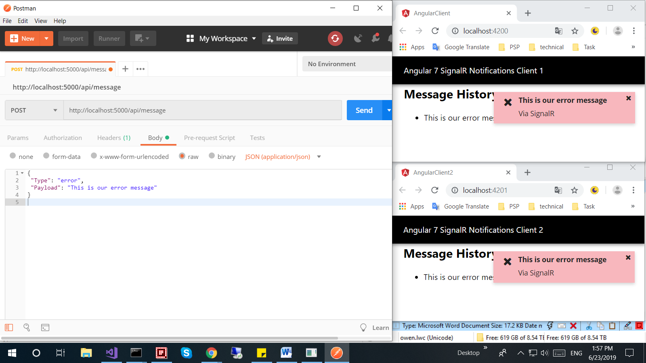 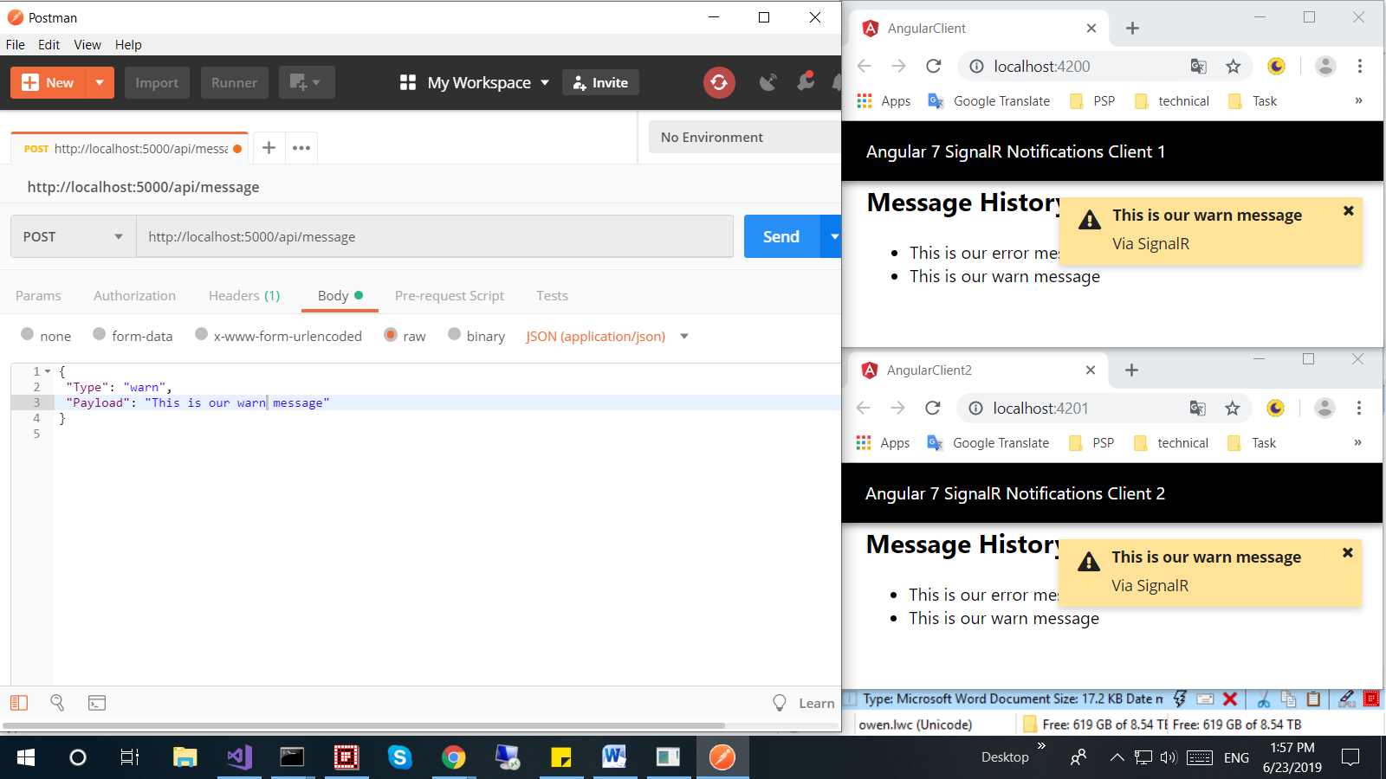 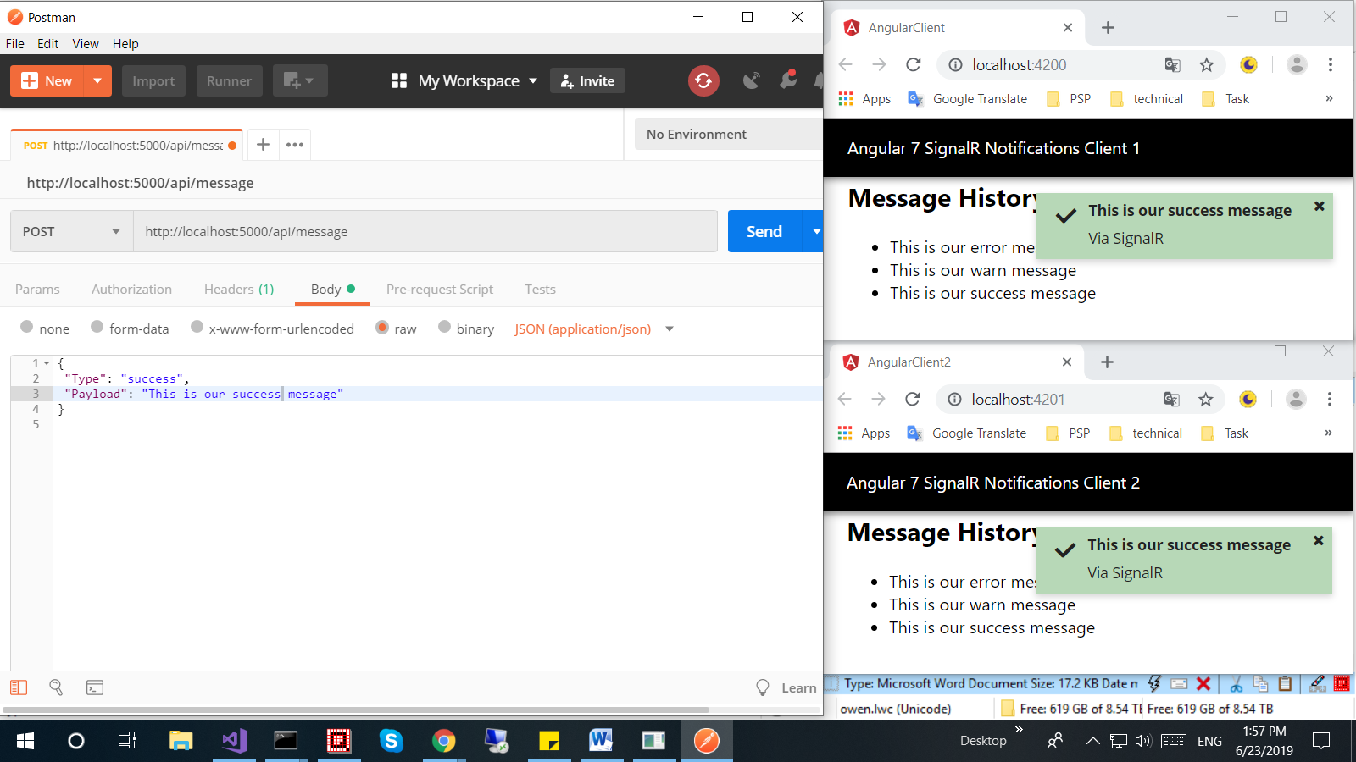 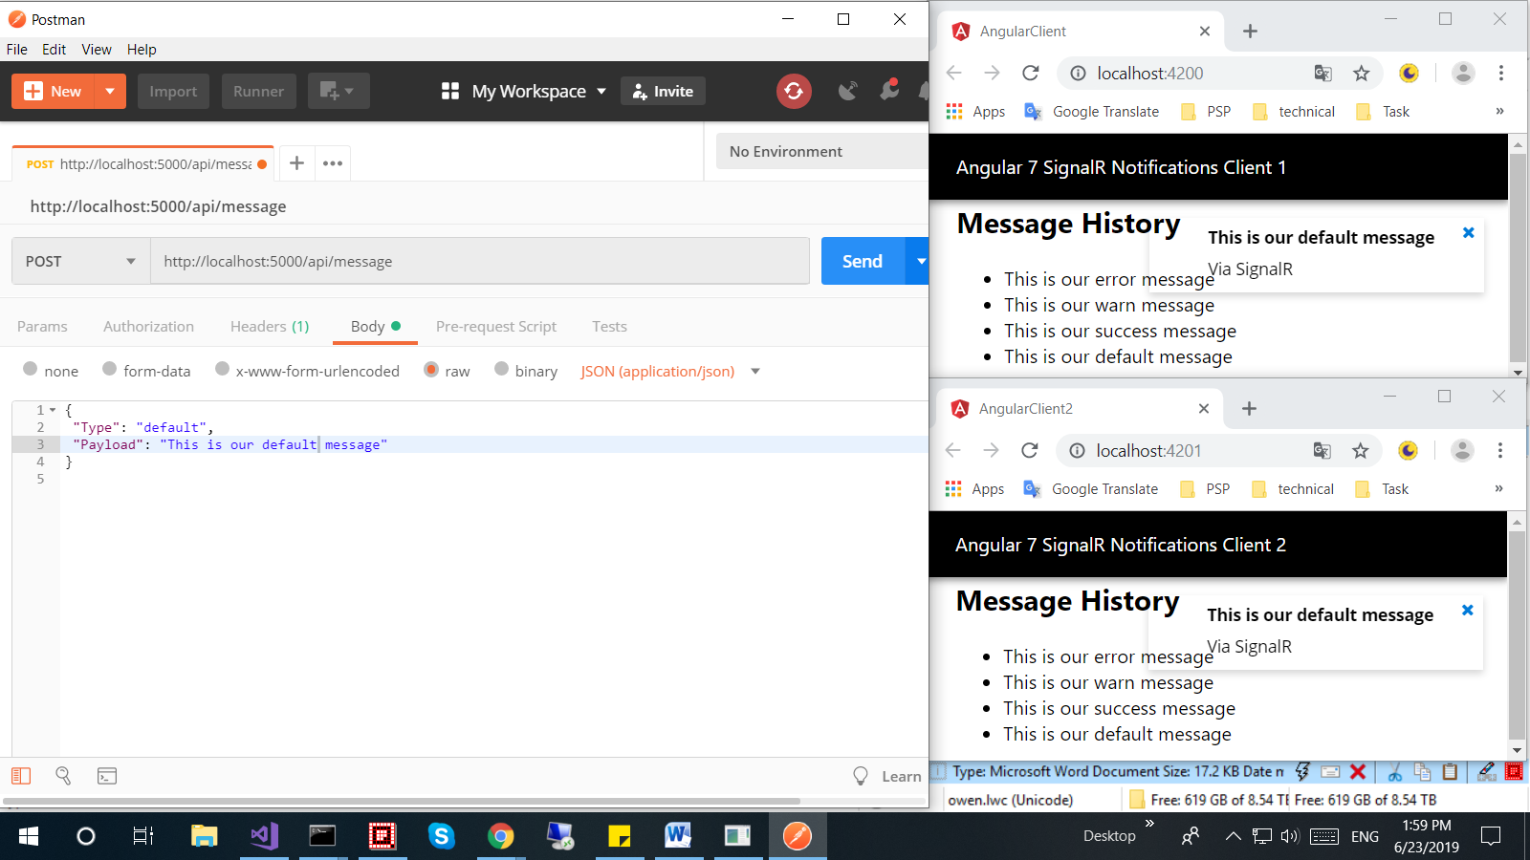

3rd approach: Notification By UserGroup.

Manage users and groups in SignalR

* <https://docs.microsoft.com/en-us/aspnet/core/signalr/groups?view=aspnetcore-2.2>

